Name: Class:

Task 1
1. What type of user interface does a smartphone have?

2. List three differences between a smartphone and a desktop PC that affect how the user interface operates.

3. Describe how a user interacts with a smartphone to do various tasks.
Consider both inputs and outputs.

Task 2
1. The diagram shows a section of RAM.
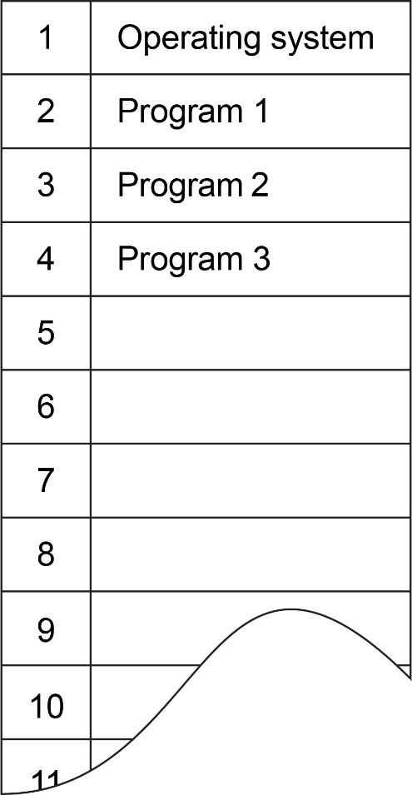
Currently, the operating system and three programs are stored in the RAM
(a) The user double clicks an icon to run a program named “Calculator”.
Describe what the operating system now does and make any suitable alterations to the diagram of RAM.

(b) Program 3 attempts to access a memory address inside location 2 (where Program 1 is located).
Explain what the operating system does.

2. Run the task manager on your computer.
On Windows computers, this can be carried out by pressing CTRL-SHIFT-ESC.
On Mac computers, load the Activity Monitor, found in Applications folder > Utilities folder
On Linux computers, make use of the “ps” command or “top” command in a terminal window.
If you cannot access your task manager, activity monitor or linux commands, your teacher may be able to demonstrate these to you.
(a) How many programs are currently loaded in memory?

(b) Whilst viewing your task manager, explain what happens when a program is opened, running and close.

Task 3
An operating system is responsible for file management.
(a) State at least three features that the operating system allows the user to carry out with files and folders or directories.

(b) Describe the processes that an operating system undertakes when a programmer writes a program to write a line of text to a file located on a magnetic hard disk.

